**Scenario #2**

**Scenario Description**

* When a player doesn’t receive any winnings. Even when a player gets a match, their balance just stays the same as before they bet.
* For example, if the player bets $5 on Prawn and the dealer rolls 2 Prawn and 1 Stag then the player gets their bet back but doesn’t gain anything. The player is meant to gain their bet back plus double as a win (e.g. $5 + $10 winnings).

**Hypothesis of problem**

From the results found in the replication and simplification of scenario problem 2, the result of the user not receiving any winnings but what they betted returning their balance to the same as before the bet would be a problem of only the bet being added to the balance after a win and not doing it twice. This problem I believe would be because the win method is only called once or the method only adds it once instead of twice.

**Location of the problem**

The location of the problem found was in the round and punter class, as after the winnings and matches won is decided in round class it calls punter.returnBet() before punter.recieveWinnings(winnings). Because of this it displays and returns the balance before the bet is returned to the balance or even removed therefore saying that the user didn’t win anything.

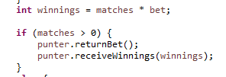

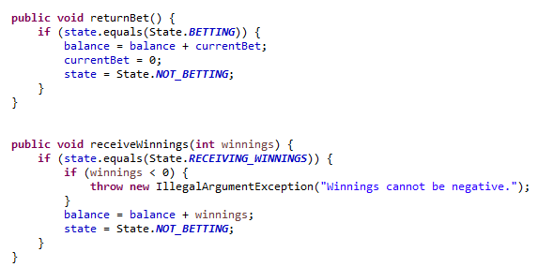

**Solution/Resolution**

To solve this problem in the program of not adding winnings to the balance or removing bet, the round class should call punter.recieveWinnings() before punter.returnBet.